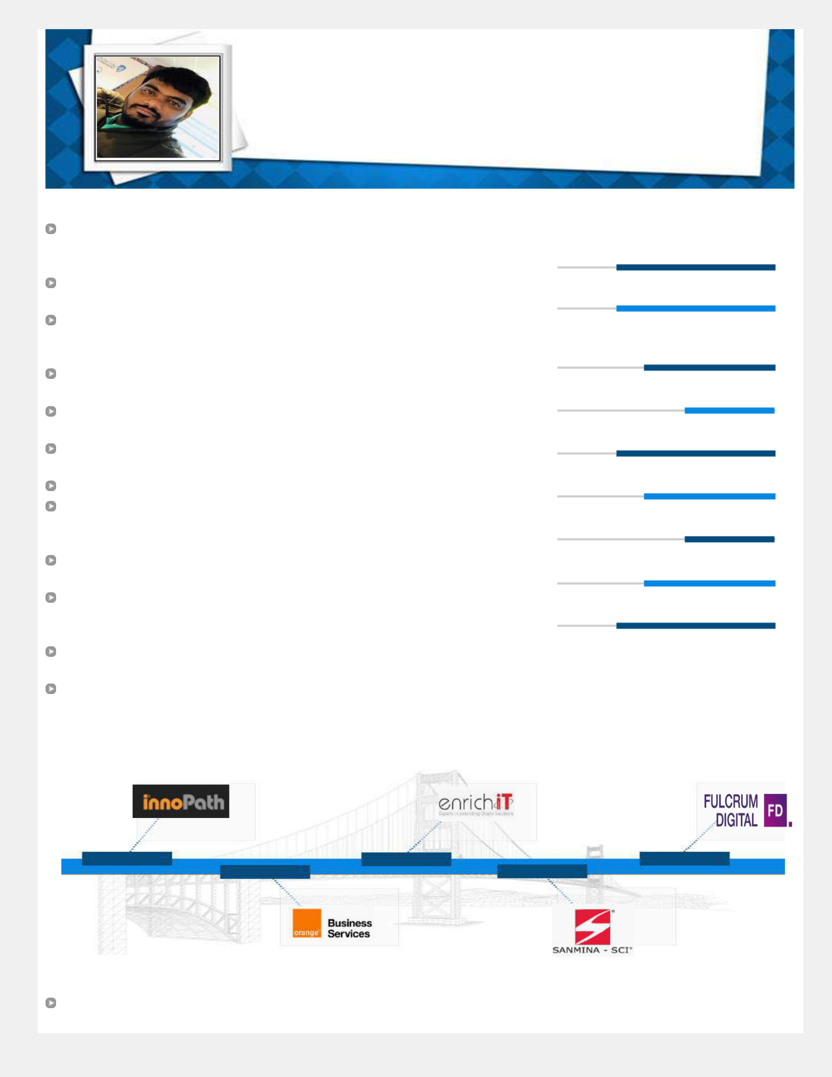**ANIL REDDY P**

**DevOps Consultant**

Versatile, high-energetic individual, targeting assignments in **Configuration** **Management/Development Operations/Build & Release** with an organization ofrepute preferably in **IT industry**

 anilreddy2317@gmail.com  +91-9515119568

Profile Summary

Dynamic & competent professional with chronicled success of **nearly a decade** of experience in **Configuration Management, Dev Ops, Build, Release & Software** **Development** with good experience **in bash scripting, knowledge on Java**

Expertise in **DevOps** methodology and tools in automating release deployment, IT Automation in Configuration Management

Analysed & understood **RFPs** for the purpose formulating appropriate response & providing solution for the same; **participate in client meetings, business discussions,** **prepared statement of work,** undertook project coordination & created project plan

Wealth of expertise entails Delivery Management, Application Development/ Management, Operations Management, Business Analysis and Requirement/Gap Analysis

Gained **international exposure** while working onsite UK, involved in migration from SVN to Bitbucket and Bamboo to Jenkins

Extensive experience in integrating **Maven** tool in **CICD** using **Jenkins, bamboo** and troubleshooting Build and Release issues as part of CICD

Expert in designing and implementing CICD for Java, Node Js and PHP applications

Hands-on experience in setting up, configuring and maintaining master/nodes Jenkins with experience on **Docker** configuration. Created Docker images and written Docker files

Gained experience in Linux, Python Scripting, Oracle DBA, Nexus Implementation, Container Orchestration (Kubernetes), and so on

Working knowledge in using **Nexus** and Artifactory Repository for Maven and Ant builds, deploying **Jboss**, **Apache Tomcat** web server and **Oracle WebLogic**, **AWS** cloud services such as EC2, IAM, VPC, S3 and ECR along with monitoring tool **Nagios**

Spearheaded **delivery management**, **profitability**, costing for projects, revenue and margin forecasting for portfolio, margin improvement planning for portfolio

**Team-based management style** coupled with the **zeal to drive visions** into realitywith exceptional **leadership skills**

 Career Timeline

 Area of Excellence

**DevOps Methodologies /Data Warehousing**

**Cloud Consultancy & Deployment**

**Quality Management/Process Improvement**

**Software Development Lifecycle**

**Design, Development, & Support**

**Documentation & Reporting**

**Project Management**

**Stakeholders Management**

**People Leadership**

|  |  |  |
| --- | --- | --- |
| **2010 - 2014** | **2015 - 2017** | **Since 2018** |
| **2017 - 2018** |
| **2014 - 2015** |  |
|  |  |  |

IT Skills

**Currently Working On**: Jenkins, Git, Ansible, Bit Bucket, Nexus, Ansible, SonarQube, Bash, Shell, Python, groovy, Maven, Java, Docker, solaris Linux andJIRA, Kubernetes

**Database**: SQL 2000,2005,2008,oracle11g,12c

**Other DevOps and Common Tools**: Putty, WinSCP, Eclipse, Jforg, TFS, MTM, Docker and gerrit, Tosca.terraform,sql developer.

 Notable Accomplishments Across The Career

Executed:

1. Multi branch pipelines in Jenkins, to trigger a pipeline when PR raised to target branch (develop)
2. **Flyway** for database deployment and integrated with Jenkins
3. **SonarQube** and managed it as a **code quality anlysis tool** to tracke trending

Defined & implemented branching & merging strategy as part of Release Management and master templates for Build & Release pipelines; used Ansible vault to encrypt sensitive information such as passwords

Wrote playbooks and roles in **Ansible** for application Deployment using released versions and snapshot versions.

Configured packages, services using Ansible modules like yum, service, templates, handlers etc.

Build new app server for deploying the applications in Apache ,jboss and weblogic server

 Work Experience

**Since Aug’18: Fulcrum, Client : Mastercard (Vacalink) as Senior DevOps Engineer**

**Jan’17 – Mar’18: Sanmina-Sci as Senior Software Engineer**

**Aug’15 – Jan’17: Enrich-IT as Senior Software Engineer**

**Aug’14 – Aug’15: Orange Business Services as Consultant**

**Nov’10 – Aug’14: InnoPath Software Inc. as Database Engineer**

**Key Result Areas:**

Steering end-to-end execution of complex & high valued projects including scheduling & negotiating with clients as per SLAs and balancing work distribution to meet deliverables as per norms

Automating build &deployment process for Java, Node Js and PHP; designing & implementing CICD for Java, Node Js and PHP applications and installing Configure and Maintain Jenkins, SonarQube, Nexus and Bit bucket.

Defining process for DevOps On-boarding and Setup of SonarQube Code Quality Analysis.

Executing test cases by executing Jenkins jobs as part of continuous testing; setting up Nexus HA in RHEL.

Allocating Version Control Branch and Environments (Dev & QA); integrating TOSCA automation testing tool with Jenkins

Working as representative for Problem Management meetings, RCA meetings, support team (application & Infra) team meetings to discuss on running issues

Assisting in effective implementation of business information systems and development & implementation of security policies as per the framework; establishing & maintaining clear communication with business sponsors, stakeholders & IT Teams

Identifying opportunities to increase revenue, improve quality & reduce cost and delivery time, conducting post-go-live reviews and implementing controls to avoid future failures; providing support to client’s AWS infrastructure, worked with various AWS services

Supervising work for Application Development and Support, Change and Release Management, Infrastructure & Service Management regarding the creation, modification and validation of configuration items

Education

**B.Tech. (Specialization)** from JNT university